Assignment 1

1.Write a program to print all the composite numbers between a and b?

Sample Input:

A = 12

B = 19

Sample Output

14, 15, 16, 18

Test cases:

1. A = 11, B = 11

2. A = 20, B = 10

3. A = 0, B = 0

4. A = -5, B = 5

5. A = 7, B = -12

CODE:

import java.util.Scanner;

public class pav{

public static void main(String[] args){

Scanner obj=new Scanner(System.in);

System.out.print("Enter starting number: ");

int a=obj.nextInt();

System.out.print("Enter ending number: ");

int b=obj.nextInt();

int i,j;

if (a>b | a==b){

System.out.println("GIVE THE STARTING AND END NUMBER PROPERLY");

}

else{

for(i=a;i<b;i++){

for(j=2;j<i;j++){

if(i%j==0){

System.out.println(i);

break;

}

}

}

}

}

}

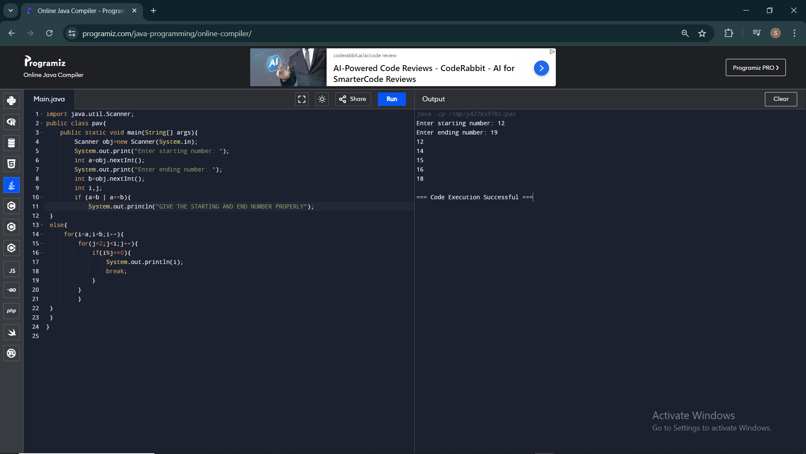

2.Write a program to print the numbers from M to N by skipping K numbers in between?

Sample Input:

M = 50

N = 100

K = 7

Sample Output:

50, 58, 66, 74, …..

Test cases:

1. M = 15, N = 05, K = 02

2. .M = 25, N = 50, K = 04

3. M = 15, N = 100, K = -02

4. M = 0 , N = 0 , K = 2

5. M = 200 , N = 200 , K = 50

CODE:

import java.util.Scanner;

public class pav{

public static void main(String[] args){

Scanner obj=new Scanner(System.in);

System.out.print("Enter starting number: ");

int a=obj.nextInt();

System.out.print("Enter ending number: ");

int b=obj.nextInt();

System.out.print("Enter skip number: ");

int k=obj.nextInt();

int i;

for(i=a;i<=b;i+=k+1){

System.out.println(i);

}

}

}

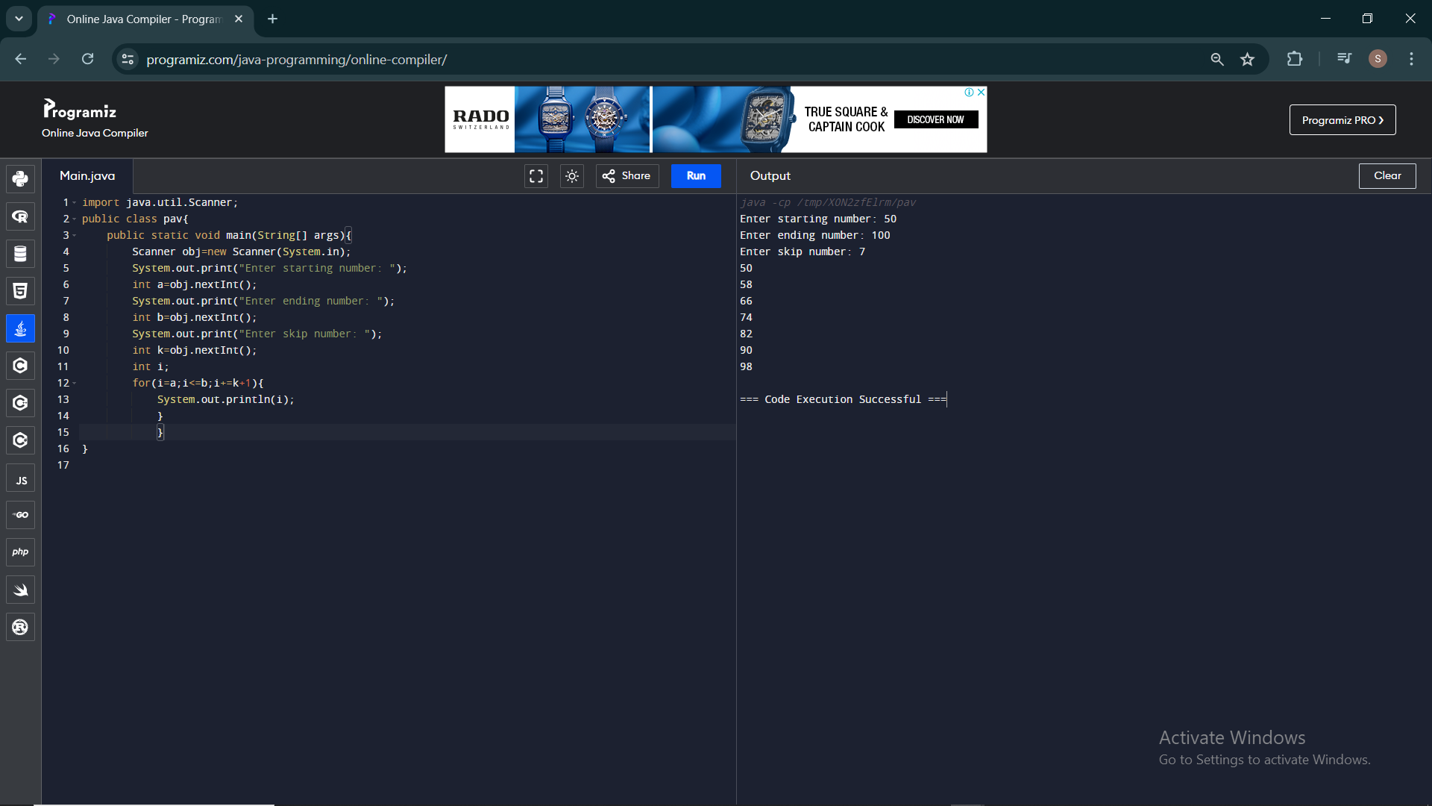

3.Write a program to enter the marks of a student in four subjects. Then calculate the total and aggregate, display the grade obtained by the student. If the student scores an aggregate greater than 75%, then the grade is Distinction. If aggregate is 60>= and <75, then the grade is First Division. If aggregate is 50 >= and <60, then the grade is Second Division. If aggregate is 40>= and <50, then the grade is Third Division. Else the grade is Fail.

Sample Input & Output:

Enter the marks in python: 90

Enter the marks in c programming: 91

Enter the marks in Mathematics: 92

Enter the marks in Physics: 93

Total= 366

Aggregate = 91.5

DISTINCTION

Test cases:

a) 18, 76,93,65

b) 73,78,79,75

c) 98,106,120,95

d) 96,73, -85,95

e) 78,59.8,76,79

CODE:

import java.util.Scanner;

public class pav{

public static void main(String[] args){

Scanner obj=new Scanner(System.in);

System.out.print("Enter Python marks: ");

float a=obj.nextFloat();

System.out.print("Enter C Programming marks: ");

float b=obj.nextFloat();

System.out.print("Enter Mathematics marks: ");

float c=obj.nextFloat();

System.out.print("Enter Physics marks: ");

float d=obj.nextFloat();

float total=a+b+c+d;

float aggregate=total/4;

System.out.println("Toatl: "+total);

System.out.println("Aggregate: "+aggregate);

if (aggregate>=75 & aggregate <=100){

System.out.print("DISTINCTION");

}

else if(aggregate>=60 & aggregate<75){

System.out.print("First Division");

}

else if(aggregate>=50 & aggregate<60){

System.out.print("Second Division");

}

else if(aggregate>=40 & aggregate<50){

System.out.println("Third Division");

}

else if(aggregate>=0 & aggregate<40){

System.out.println("Fail");

}

}

}

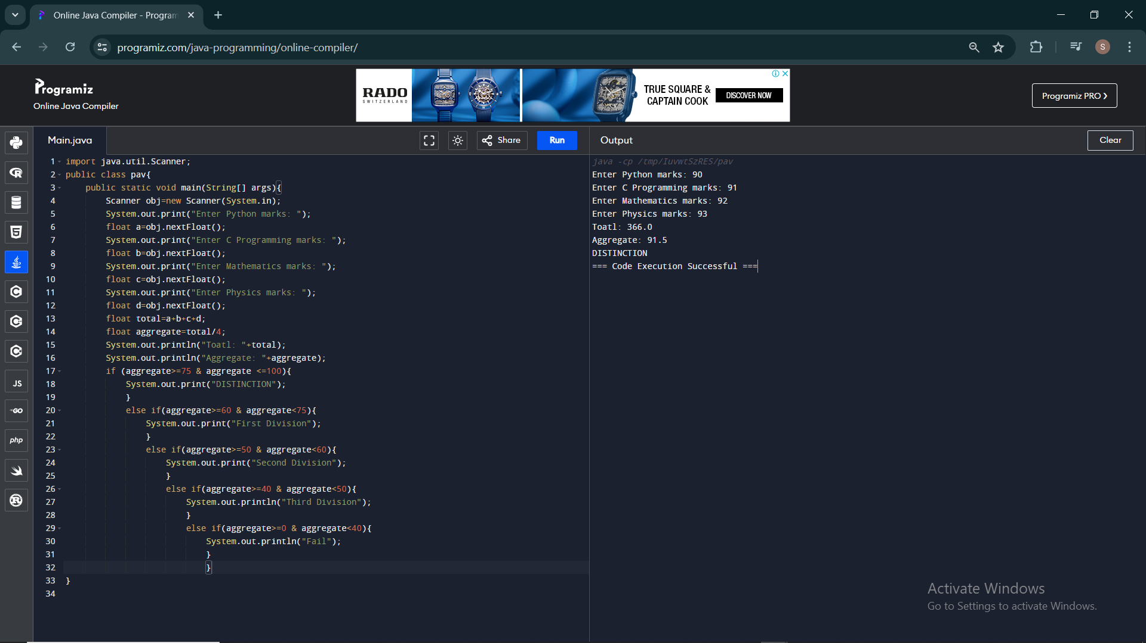

4.Write a program to calculate tax given the following conditions:

a. If income is less than or equal to 1,50,000 then no tax

b. If taxable income is 1,50,001 – 3,00,000 the charge 10% tax

c. If taxable income is 3,00,001 – 5,00,000 the charge 20% tax

d. If taxable income is above 5,00,001 then charge 30% tax

Sample Input:

Enter the income:200000

Sample Output:

Tax= 20000

Test cases:

1. 400700

2. 2789239

3. 150000

4. 00000

5. -125486

CODE:

import java.util.Scanner;

public class pav{

public static void main(String[] args){

Scanner obj=new Scanner(System.in);

System.out.print("Enter Income: ");

float temp=obj.nextFloat();

double b=0;

if (temp>=0 & temp<=150000){

System.out.print("NO TAX");

}

else if(temp>150001 & temp<=300000){

b=temp\*0.1;

System.out.print("Tax = "+b);

}

else if(temp>300001 & temp<=500000){

b=temp\*0.2;

System.out.print("Tax = "+b);

}

else if(temp>500001){

b=temp\*0.3;

System.out.print("Tax = "+b);

}

}

}

